A Guide to Argument Mapping Materials

Jamel Ostwald (History)
Eastern Connecticut State University, Critical Thinking Workgroup



Table of Contents
Introduction
Quick Start Guide
I. Overview of Rationale Software
II. Online Materials
III. Other Austhink Website Materials
IV. Other Websites with Argument Mapping Materials
V. Rationale Help Files

Note: If you are viewing this document in Microsoft word, the blue underlined text are active hyperlinks. Control-clicking on them will open up the appropriate webpage in your default browser.

Introduction
Argument mapping is a way of visually representing the logical structure of an argument. It deals with the realm of informal (usually inductive) logic, i.e. the types of arguments that people have everyday both in and out of academia. It does so by having the user break a prose argument up into its constituent claims and evidence (reasons), placing each of these textual statements in a box and then illustrating the logical/evidential relationships between them through 1) lines connecting the boxes, 2) the color of the box, and 3) their spatial locations relative to one another. Complex arguments are built up of chains (or webs) of these simple arguments.

A few clarifications are important early on:
- Argument mapping is best used for deliberation, deciding whether a claim is true (or warranted, or likely to be true). It is not ideal for comparing competing explanations of a particular event (see my Tutorial #2 pp. 2-5 for an overview of the difference between reasons and explanations).
- You do not necessarily need to use the Rationale software to map an argument – you can map out an argument on paper or blackboard, or use post-it notes. However, if you want to map your arguments easily (e.g. move boxes around) and save your maps, reproduce copies of them, etc., then you need software, and Rationale is the best for this purpose.
- The software is not “intelligent” – it will not fix your logic for you or clarify muddled thinking all by itself. Argument mapping software is intended only to make it easy for you to follow a process that will improve the logical consistency of your thinking, help evaluate mapped arguments, and efficiently display your argument – the user still has to do the mental work (hence the benefits to critical thinking). The Austhink website discusses all this in far more detail.

The company behind Rationale, Austhink, has developed numerous guides and tutorials to help you get started with argument mapping using Rationale. What follows is a brief overview of the materials available.

Generally speaking, there are several types of materials, all available either online or in the Rationale software Help files:
- Materials introducing the concept of argument mapping.
- Materials describing how to use the Rationale software to map arguments.
- Detailed tutorials explaining the process of argument mapping.
- Pedagogical articles on argument mapping and critical thinking.
- Miscellaneous websites that include wikis, blogs and email listservs dedicated to argument mapping and the Rationale software.

These materials exist for both teachers and students, ranging from Grade School to College level. The best way to go through the materials would be to explore the Austhink website systematically. Since there are so many materials, I’ve included below an overview of what’s available.

Quick Start Guide
If you want to just dive in, I’d suggest the following:
1. Read Austhink’s One Minute Mapper pdf, at http://www.austhink.com/pdf/One_minute_mapper.pdf
2. Read my 2-page handout on argument mapping, at www.jostwald.com/ArgumentMapping/OstwaldHandout.pdf.
3. You should then look at some more detailed examinations of the process. The software is simple to use, so you should focus on learning the argument mapping process. In one sense the process is easy, since it does no more than encourage you to follow the basic rules of informal logic, but the devil is in the details as we quickly learn when trying to specify the various parts of other people’s arguments. Materials for beginning students include the exercises within Rationale (also online). Those more advanced (including faculty) could start with my tutorials, or with Austhink’s tutorials. I would particularly recommend that you learn and apply the heuristics developed by Austhink (covered in my Tutorials #3-#4, and discussed more expansively in Austhink’s tutorials).
4. As Austhink stresses, the critical thinking benefits of argument mapping only come from frequent use – their exercises and tutorials provide many examples to practice, and our Critical Thinking workgroup has more complex examples we can share as well. The CT workgroup members will also help grant participants develop argument maps based on their own course content.

The following essay offers a particularly good explanation of the benefits of argument mapping: http://www.austhink.com/monk/Fenner/Fenner.htm. For comparison with other types of mapping, see http://www.austhink.com/pdf/Argument_Mapping_at_Work.pdf.

If you’re interested in the pedagogy of argument mapping, the webpage http://www.austhink.com/education/ is a good start. See especially Twardy’s essay at http://www.csse.monash.edu.au/~ctwardy/Papers/reasonpaper.pdf.
Austhink’s Educators’ Guides, at http://www.austhink.com/education/#Key%20Concepts%20in%20Reasoning, provide discussion of curriculum application.

If you would like to test the software, go to www.austhink.com and download the free 30-day demo of Rationale (PC only). The software is quite inexpensive (approx. $50 for a perpetual academic license), and those using argument mapping in their First Year classes as grant participants will receive a 1-year license of the Rationale software. Copies of the software will also be available for use in the 4th floor Webb computer lab.

I. Overview of Rationale software
Background: The Austhink group and its Reason Project is based out of Australia, founded by University of Melbourne professor Tim van Gelder. Several years ago they created an early software package to map arguments, called Reason!able. In 2006 Reason!able was replaced by Rationale, and is being updated and improved frequently.

The Rationale software has 4 basic ‘modes’ (Grouping, Reasoning, Analysis, Basis Boxes), but at the college-level the one you should use most is Analysis, because it forces you to identify important assumptions that often go unstated and unexamined.

The ‘Reasoning’ mode creates relatively simple maps that look like:
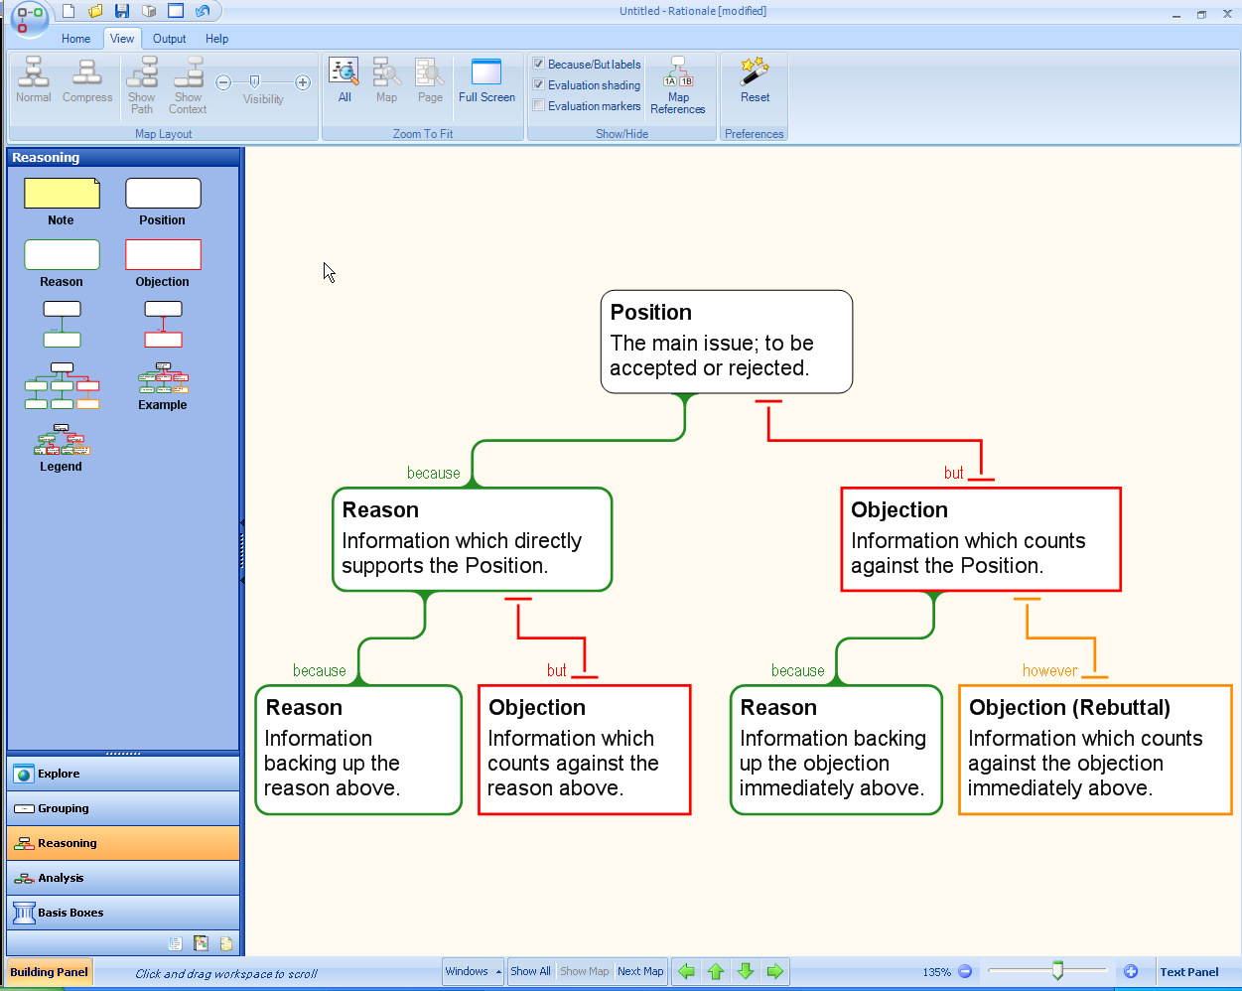
Notice that mapping makes it clear which statement serves as the main conclusion, which serve as reasons to believe that conclusion, and which statements are intended as objections to which claims. Thus you can map out an entire debate rather than just a single position.

The ‘Analysis’ mode creates more detailed maps that force you to identify assumptions (copremises) that go along with each reason. Below is the same basic map as above with each box ‘unfolded’ to show the copremises that go with each claim:
Note that the software allows you to label each box for easier identification.

You can also use the software to evaluate the strength of the argument – you rate the strength of each reason and objection before pronouncing on the main conclusion’s likelihood of being true or warranted.

II. Online Materials
Most of the materials on argument mapping and Rationale are available online. Many of them can be accessed from within Rationale itself, using the Explore pane. From within the Explore pane of the Rationale software, you see the following links:
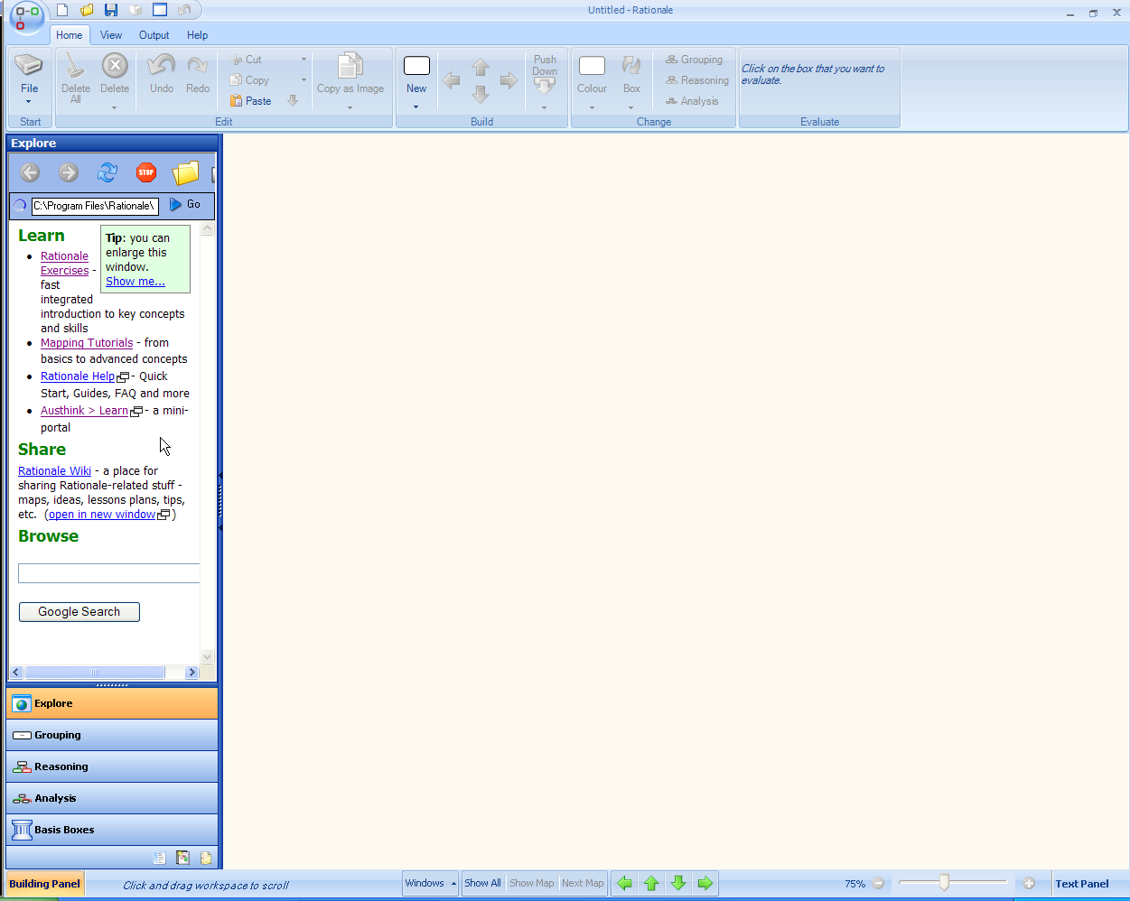
Zoomed in, you see the following:

Learn
- Rationale Exercises - fast integrated introduction to key concepts and skills
- Mapping Tutorials - from basics to advanced concepts
- Rationale Help- Quick Start, Guides, FAQ and more (requires the software)
- Austhink > Learn- a mini-portal

Share
Rationale Wiki - a place for sharing Rationale-related stuff - maps, ideas, lessons plans, tips, etc. (open in new window)
Top of Form
- The Bottom of Form
Interactive Exercises are best suited for students learning the basics. They include:
Set 1 Grouping
Set 2 Argument Parts
Set 3 Indicators
Set 4 Refining Claims
Set 5 Locating Arguments
Set 6 Essays
Set 7 Basis Boxes
Set 8 Assessing
Set 9 More on Assessing
Set 10 Analysis Maps
Set 11 Assessing Again
Set 12 A challenge
These are viewable at http://learn.austhink.com/rationale/exercises/. Austhink estimates that each set should take students about 15 minutes to complete (Set 12 is a longer capstone). Faculty members should supplement the above exercises with their own examples (esp. Set 12).

- The Mapping Tutorials are longer tutorials used in a semester-long Critical Thinking course taught at the University of Melbourne using argument mapping. They include lots of examples and exercises, but the unifying example is an article on whether the moon landing was faked or not. If you want to get lots of practice and see the various definitions used in argument mapping, then this is the place.
It’s online at http://www.austhink.com/reason/tutorials/. The Table of Contents:

Before you start...
Useful introductory information about argument mapping and these tutorials. Includes some technical tips.
Tutorial 1 - Simple Arguments
Introduces simple arguments, the most basic units of reasoning. Discusses various kinds, their parts, and how to map them.

Tutorial 2 - Simple Argument Structure
Looks in more detail at the internal structure of simple arguments. Gives simple guidelines for identifying assumptions and ensuring that the whole thing hangs together properly.

Tutorial 3 - Multi-Reason Arguments
Studies arguments in which more than one reason or objection bear upon a single claim. Discusses some common mistakes in mapping such arguments.

Tutorial 4 - Multi-Layer Arguments
In multi-layer arguments, reasons or objections are themselves supported or opposed by further arguments. This tutorial covers the main kinds of multi-layer arguments, how to map them, and how to avoid some common errors.

Tutorial 5 - Inference Objections
Inference objections are a kind of multi-layer argument, and mapping them is particularly challenging. This tutorial shows how to map inference objections as objections to hidden premises.

Tutorial 6 - Macrostructure
The "macrostructure" is the structure of complex arguments on a large scale. This tutorial covers some fundamental principles for producing maps of well-structured complex arguments.

- The Rationale Help files are only accessible from within the software, and provide more guides to the argument mapping process, as well as Step-by-Step instructions for using the software to create argument maps. See V. below for details.

III. Other Austhink Website Materials
The Rationale website (www.austhink.com) has many other handouts as well. The Learn page has the following:
Bottom of Form

Learn
We have a number of different resources to assist you with argument mapping and using Rationale™:

Argument Mapping
What is argument mapping? Why is it useful? Why should I map? How does it help with critical thinking? Find out here!

The One-Minute Mapper
Short of time or need a refresher? Check out The One-Minute Mapper (pdf) - it's two pages long, and one's all pictures!

Free Online Argument Mapping Tutorials
Six tutorials covering the fundamentals of argument mapping.

Extensive built-in help
Rationale™ has comprehensive help built-in help including Quick Start, FAQ and guides to Grouping, Reasoning, Analysis, Essay Planning and Exporting.

Rationale Discussion Forum
Join the Rationale Google Group and particpate in discussions of all things Rationale and argument mapping.

Guides and FAQs
Support Materials including
- Educators' guides
- Argument Mapping at Work (pdf)
- FAQs - Using Rationale™
- The One-Minute Mapper

Training courses
Austhink provides a range of training services in critical thinking skills, ranging from 2 hour modules to workshops of up to 7 days.
- Training for Professionals
- Training for Educators

Some of these we’ve already seen from within Rationale itself, but the Educators’ Guides might be of interest (thus far they only have Primary and Secondary Educators’ Guides finished).

Austhink is also working on a Solution Pack and Tertiary Educators’ Guide that promise to make it easy for higher ed faculty to apply argument mapping to their own courses which are not dedicated to solely critical thinking.
IV. Other Websites with Argument Mapping materials
Argument mapping is starting to catch on (subscribe to Austhink’s Ratatouille newsletter for the latest news), and a number of websites have posted some of their argument mapping materials online. Many of these are listed on the Austhink website.

Austhink also has its own blog, a wiki site where members can post their own maps and materials, and Tim van Gelder has a blog dedicated to argument mapping as well, at http://rtnl.wordpress.com/.

We should also mention the tutorials Jamel Ostwald created for some of his Eastern Connecticut State students, currently available at www.jostwald.com/ArgumentMapping. These are a bit more explanatory than the interactive exercises in Rationale, and are based on the concepts used in Austhink’s longer Mapping Tutorials.
The Content of these tutorials:
Argument Mapping tutorial #1 - Introduction
Argument Mapping tutorial #2 - Claims and Reasons
Argument Mapping tutorial #3 - Boxes and arrows
Argument Mapping tutorial #4 - Identifying Assumptions (copremises)
Argument Mapping tutorial #5 - Objections
Argument Mapping tutorial #6 - Model Maps
Argument Mapping tutorial #7 - Prose to Map
Argument Mapping tutorial #8 - Claims Tables

V. Rationale Help Files
The Rationale software includes additional resources. Below is a screenshot of the Help Contents. Notice the Step-by-step instructions which explain how to build argument maps within Rationale.
